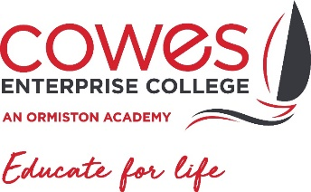
Exam certificates contact confirmation 2022
In order for us to post home your exam certificates we will need to confirm your contact details below. Your certificates will be posted home to you in the New Year via Royal Mail recorded delivery. In the event certificates are returned, we will only hold onto them for one year, after which they will be destroyed in line with GDPR guidance. Once destroyed students would need to contact the exam boards directly for copies, this can be costly and not all exam boards provide replacements.
Student Name:
Year Group Studied:
Student Address:
Student Mobile:
Student Personal Email:
I can confirm that the details given above are correct. If my details change I will contact Cowes Enterprise College and update my information. I am aware that if I move and do not inform the college of the change that my certificates will be destroyed after one year and I may not be able to get duplicates.

Data Protection Act 1998: Cowes Enterprise College is registered under the Data Protection Act for holding personal data. The college has a duty to protect this information and to keep it up to date. The college is required to share some of the data with the Local Authority and with the DFE. A privacy notice explaining how we handle personal data of parents/carers and students is available to view on our website (https://www.cowesec.org/assets/docs/OAT-Privacy-notice-for-pupils-v0.4.docx-1.pdf). Should you have any further questions, please do not hesitate to contact the college directly.

Signed: |  | Date:

PLEASE HAND THIS FORM INTO RECEPTION BEFORE LEAVING THE COLLEGE SITE or send to exams@cowesec.org

